**Cohort analysis**

Cohort is Group of users who share common characteristics.

When we measure their performance over a period of time it is called cohort analysis.

Case if we want to analyze the users acquired in a year and their performance in the following years.

Create a bar chart as follows

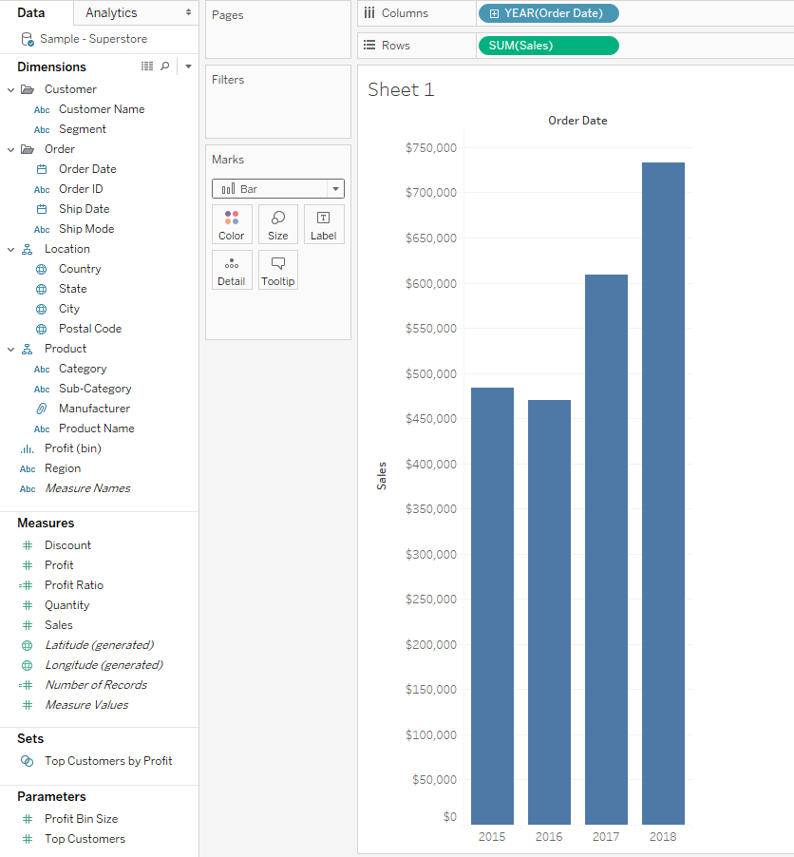

We want to know how much is the share of customers in 2015 in the following years.

Create a calculated field to capture the first order date of the customer.

**Year of acquisition**

**{ FIXED [Customer Name]:MIN([Order Date])}**

**Drag the calculated field to the colors shelf. And show labels**

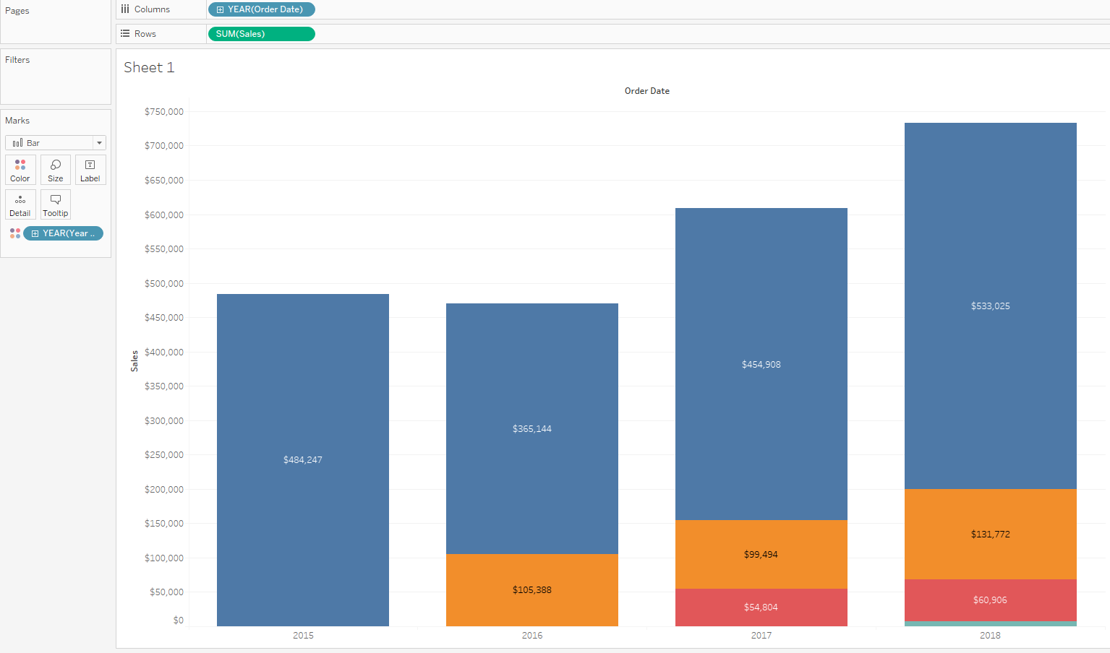

**To verify the retention customers.**

**Duplicate the sheet and remove the sum(sales) and drag the customer name to the rows shelf and change it to countd.**

**To change the numbers to % perform quick table calculation and change it to percent of total.**

**Change the compute using year of acquisition in the countd(customer name) you will get a result like the one below.**

